W2012864 7BUIS010W Coursework
Question 1
  - Transaction Entities and their corresponding functional dependencies
Transaction Entity | Functional Dependency
Fact_Citizen_Quarantine | citizenId, quarantineId, startDateId, endDateId → quarantine event
Fact_Citizen_Vaccine | citizenId, vaccineId, dateId, healthUnitId → vaccination event
Fact_Patient | patientId, diseaseVariantId, dateId, patientStatusId → patient case event
Fact_Patient_Drug | patientId, drugId, startDateId, endDateId, dose → drug treatment event
Fact_Citizen_Venues | citizenId, venueId, dateId → citizen movement event

  - Component Entities and their corresponding functional dependencies
Component Entity | Functional Dependency
Dim_Citizen | citizenId → name, surname, gender, DOB, weight, height, phoneNumber, address, districtId
Dim_HealthUnit | healthUnitId → healthUnitName, address, districtId
Dim_PatientStatus | patientStatusId → patientStatusName
Dim_Quarantine | quarantineId → quarantineName, numberOfDays
Dim_Vaccine | vaccineId → vaccineName
Dim_Venue | venueId → venueType, venueAddress
Dim_Drug | drugId → drugName, forDisease
Dim_DiseaseVariant | diseaseVariantId → diseaseId, variantName

  - Classification Entities and their corresponding functional dependencies
Classification Entity | Functional Dependency
Dim_Time | dateId → date, yearId, monthId, weekId, dayOfWeekId
Dim_DiseaseVariant | diseaseId → variantName
Dim_HealthUnit | districtId → healthUnitId, healthUnitName
Dim_Venue | venueType → venueId, venueAddress
Dim_Drug | forDisease → drugId, drugName

  - Attribute Tree
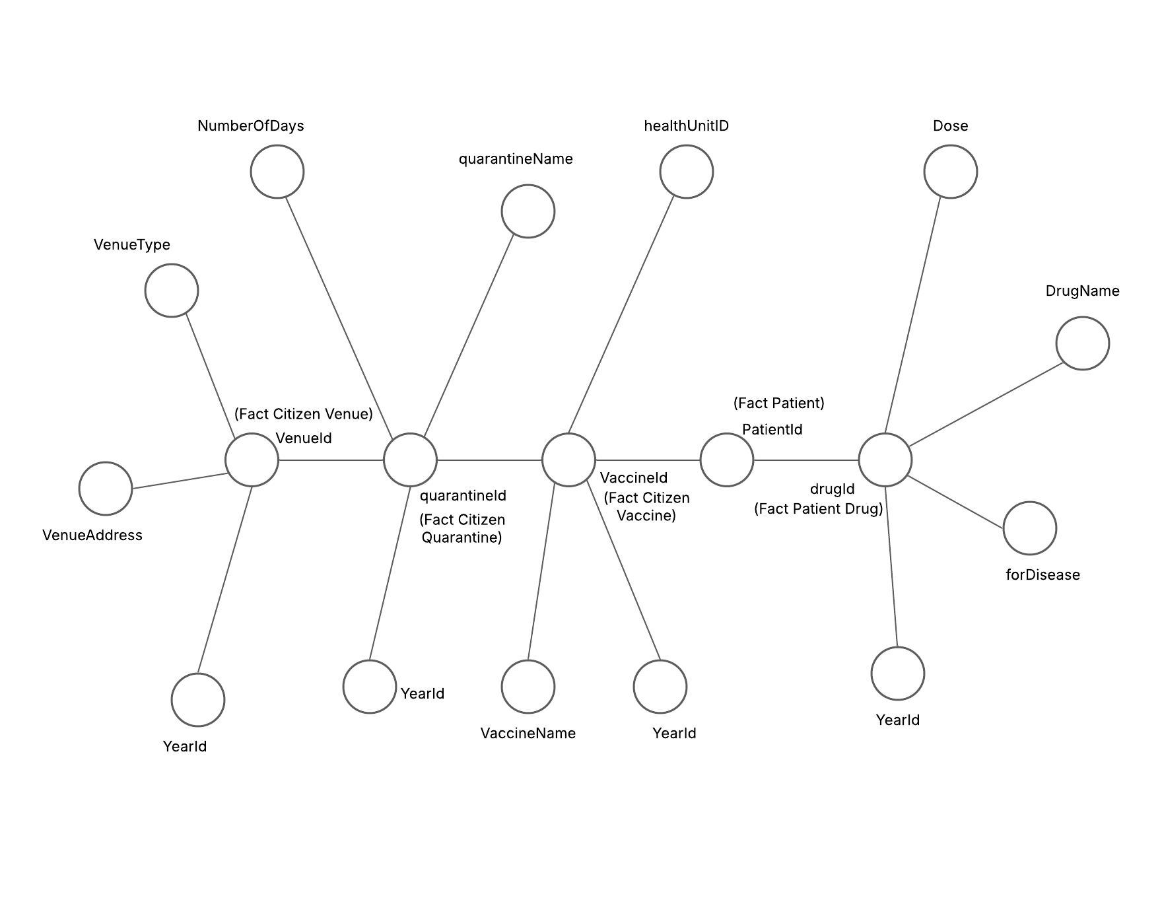

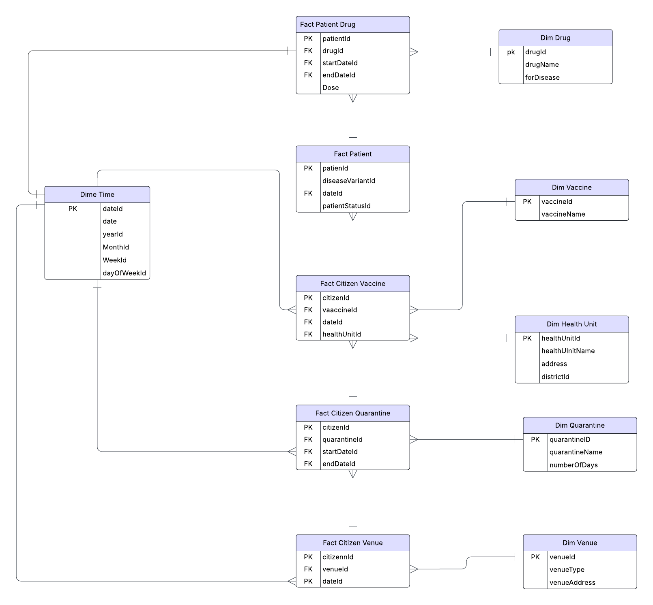
  - Dimensional Fact Model

Question 2

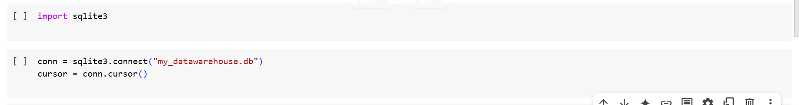
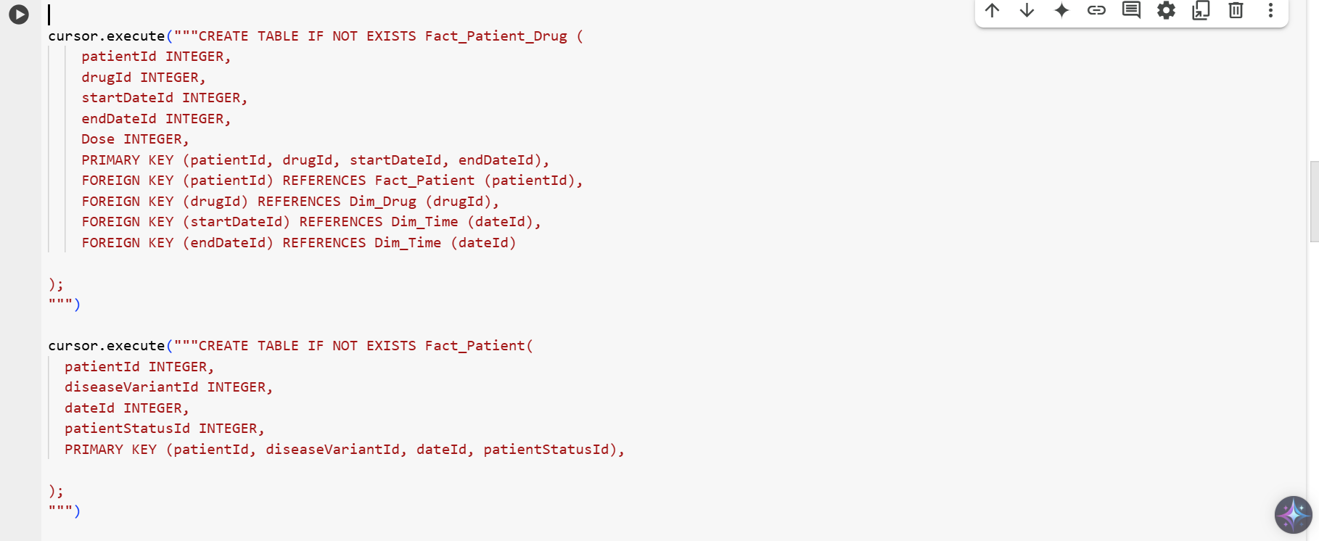
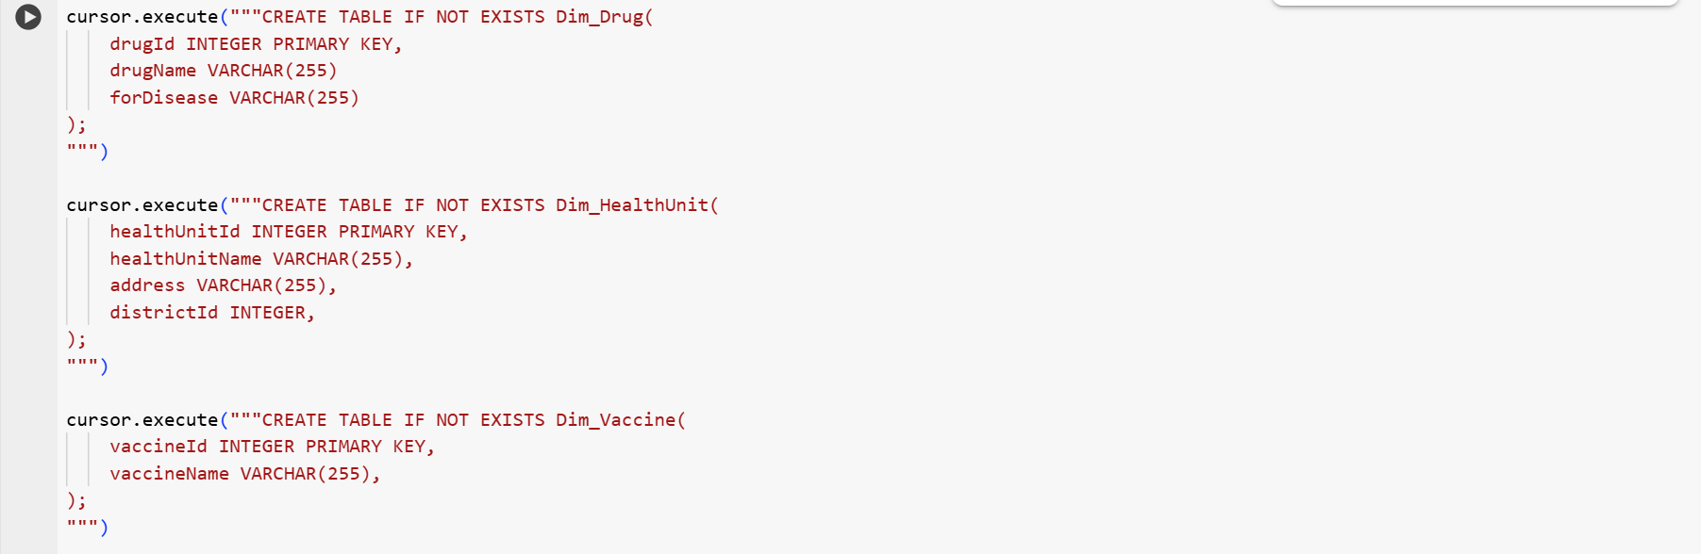

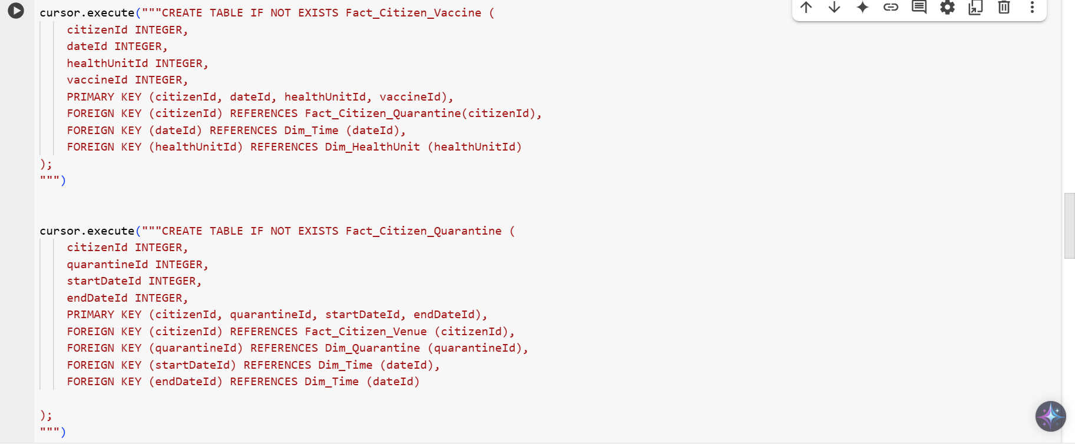

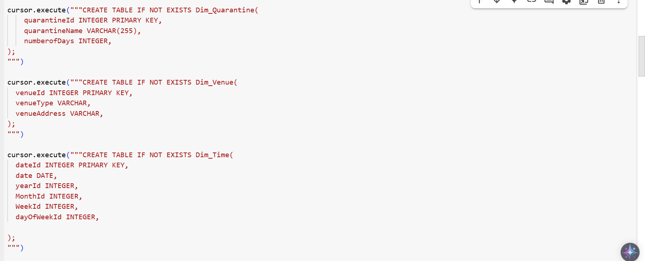

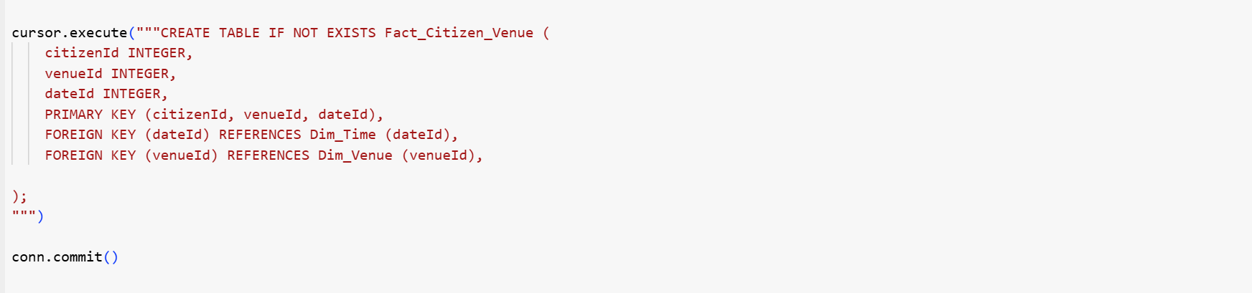
Question 3
Materialised Views for Optimising Query Response Time
To improve the response time of frequent queries Q1 and Q2, materialised views are used to precompute and store aggregated results, reducing the need for repeated calculations.
Chosen Materialised Views and Justification
- MV_Q1: COVID-19 Cases, Vaccinations, Quarantine, and Drug Treatments Per Venue and Month
This view will store pre-aggregated data for each venue and month, avoiding expensive joins across fact tables. Since Q1 requires multiple aggregations (COUNT, SUM) across venues, having the data precomputed significantly improves query performance.
- MV_Q2: COVID-19 Cases, Quarantine, and Drug Treatments Per Month
Q2 focuses on monthly trends, so a materialised view summarising total cases, quarantines, and treatments per month will speed up analysis. This reduces the need for scanning large fact tables each time the query runs.
Reasons for These Choices
- Precomputes common aggregations to enable faster retrieval of data.
- Reduces computational load by minimising the need for repeated joins and calculations on large datasets.
- Optimised for OLAP operations, supporting efficient drill-downs and filtering for analysis.
By materialising these views, queries Q1 and Q2 will execute more efficiently, enhancing the performance of the data warehouse for frequent reporting.

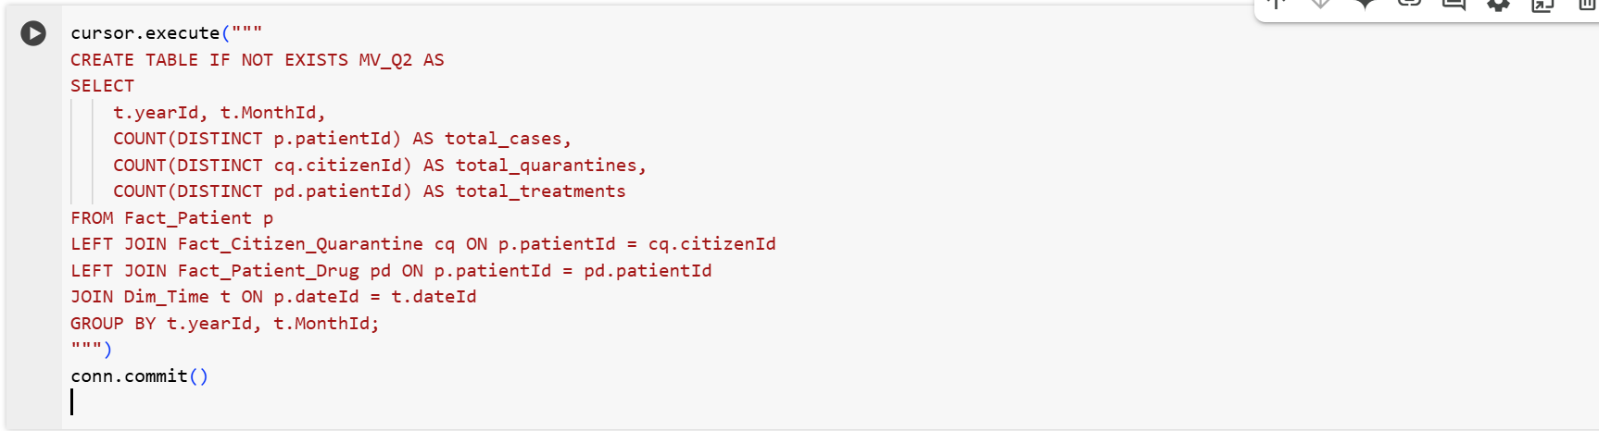
Question 4
